**WEBSITE TRAFFIC ANALYSIS**

|  |
| --- |
|  |
|  |

### OBJECTIVE :

The primary objective of website traffic analysis is to gain insights into how users interact with a website, understand user behavior, and measure the effectiveness of the website's performance. It helps in assessing various metrics such as the number of visitors, page views, session duration, bounce rate, and conversion rates. This data can then be used to make informed decisions to improve the website's content, design, and marketing strategies to enhance user engagement and achieve business goals.IBM Cognos provides robust data visualization capabilities that enable users to create insightful and interactive visual representations of their data. To create data visualizations using IBM Cognos, you can utilize its various features, such as creating dashboards, reports, and scorecards. The platform offers a wide range of visualization options, including charts, graphs, and maps, which can be customized to meet specific business needs. By leveraging IBM Cognos, users can present complex data in a simplified and meaningful manner, enabling better decision-making and analysis.

### DATA VISUALISATION USING IBM COGNOS:

By following these steps, you can effectively leverage IBM Cognos for data visualization, enabling you to gain valuable insights from your data and communicate them clearly to your team or stakeholders.

**To create data visualizations using IBM Cognos, you can follow these general steps:**

1. **Data Source Connection:** Connect IBM Cognos to your data source, whether it's a database, a data warehouse, or a file.
2. **Create a Report**: Use the report authoring tool to design and build a report based on your data source. You can select the appropriate data fields and define any necessary filters.
3. **Choose Visualization Type:** Select the type of visualization you want to use for your data. IBM Cognos offers various options such as bar charts, line charts, pie charts, and more.
4. **Customize Visualizations**: Customize the visualizations by adjusting colors, labels, and formatting options to make them more appealing and informative.
5. **Add Interactivity:** Incorporate interactivity by enabling features such as drill- down, sorting, and filtering to allow users to explore the data in more depth.
6. **Create Dashboards**: Assemble multiple visualizations into a dashboard for a comprehensive view of the data. Arrange the visualizations in a meaningful way to convey key insights effectively.
7. **Share and Distribute:** Once the visualizations and dashboards are ready, you can share them with others within your organization, allowing stakeholders to access and analyze the data for informed decision-making.

### IBM Cognos Analytics provides a variety of data visualization capabilities that can be used to create informative and engaging reports and dashboards. Some of the key features of Cognos Analytics data visualization include:

* A wide range of visualization types: Cognos Analytics includes over 30 different visualization types, including charts, maps, and tables. This allows you to choose the right visualization type for your data and the message you want to communicate.
* Interactivity: Cognos Analytics visualizations are interactive, allowing users to drill down into the data, filter by different dimensions, and compare different metrics. This makes it easy for users to explore the data and discover insights.
* Customization: Cognos Analytics visualizations can be customized to match your branding and style. You can also add text, images, and other elements to your visualizations to provide additional context and information.

Here are some examples of how you can use IBM Cognos Analytics data visualization:

* Create a bar chart to compare sales performance across different regions.
* Use a line chart to track sales trends over time.
* Create a pie chart to show the distribution of customers by age group.
* Use a map to visualize customer locations.
* Create a crosstab to compare sales performance across different product categories and regions.
* Use a dashboard to display multiple visualizations together, providing a comprehensive overview of your data.

To create a visualization in Cognos Analytics, you can use the visualization editor or the report wizard. The visualization editor provides more flexibility and control, while the report wizard is a good option for creating quick and simple visualizations.

Here are some tips for creating effective data visualizations in Cognos Analytics:

* Choose the right visualization type for your data and the message you want to communicate.
* Use color and other visual elements to highlight important trends and patterns.
* Label your visualizations clearly and concisely.
* Add text, images, and other elements to your visualizations to provide additional context and information.
* Test your visualizations with different users to make sure they are easy to understand and interpret.

IBM Cognos Analytics is a powerful data visualization tool that can help you to create informative and engaging reports and dashboards. By following the tips above, you can create visualizations that will help your audience to understand your data and make better decisions.

# Visualizing or Working with IBM Cognos:

## 1.Creating dash boards:

**A.**Visualising data with respect to worked for Day of Week by Day using pie chart representation:

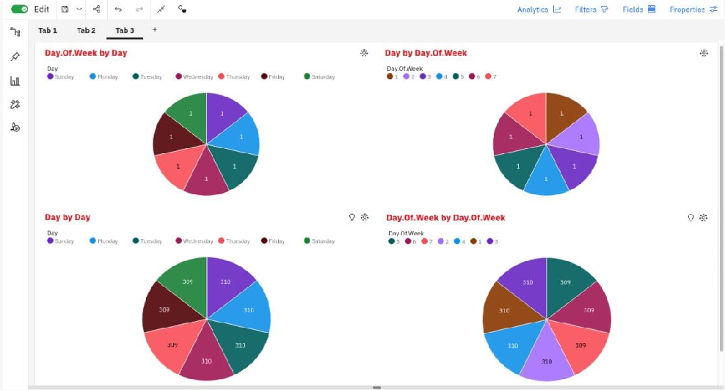

1. Visualising data with respect to worked for Day of Week by Day using Heat Map representation:

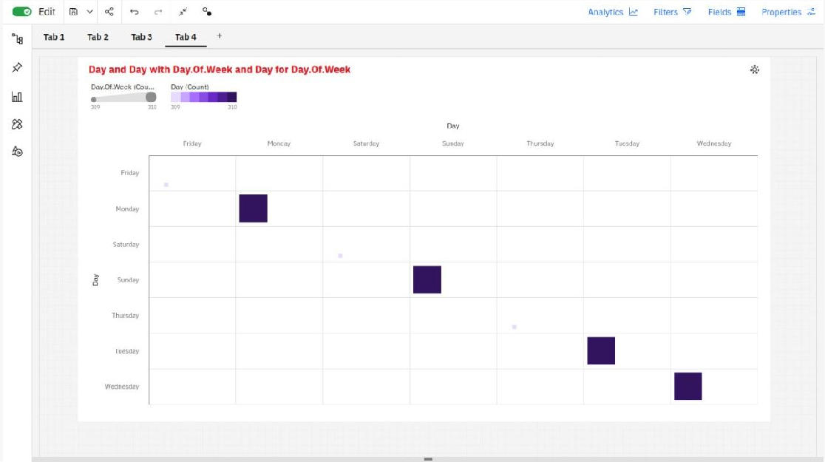

1. Visualising data with respect to worked for Day of Week by Day using Bar Chart representation:

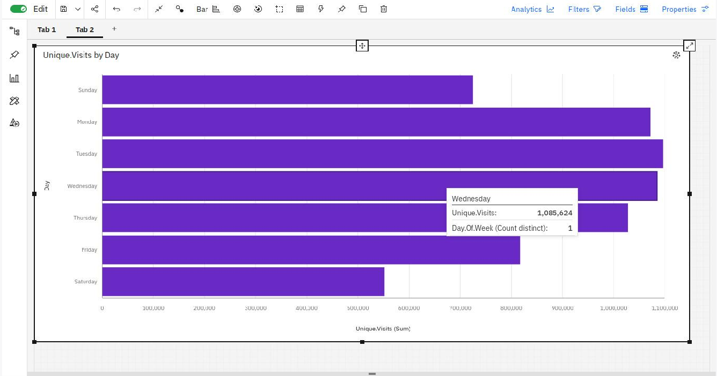

1. Visualising data with respect to worked for Day of Week by Day using Line and Column representation:

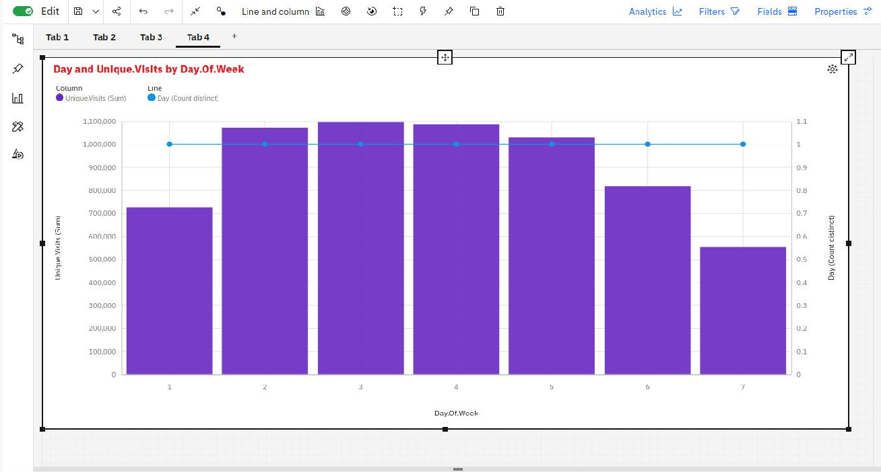

1. Visualising data with respect to worked for Day of Week by Day using Bubble Map representation:

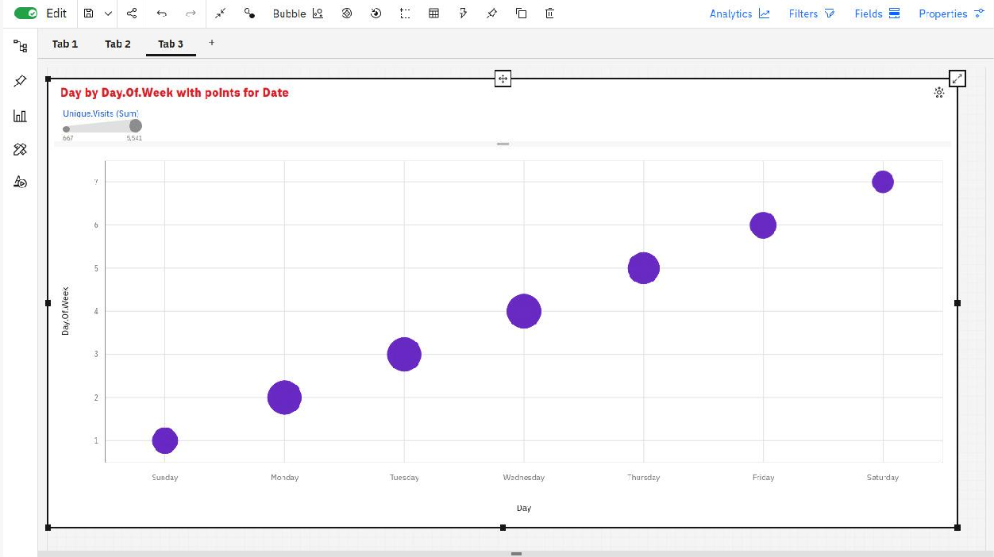

1. Visualising data with respect to worked for Page Load by Day using Area Map representation:

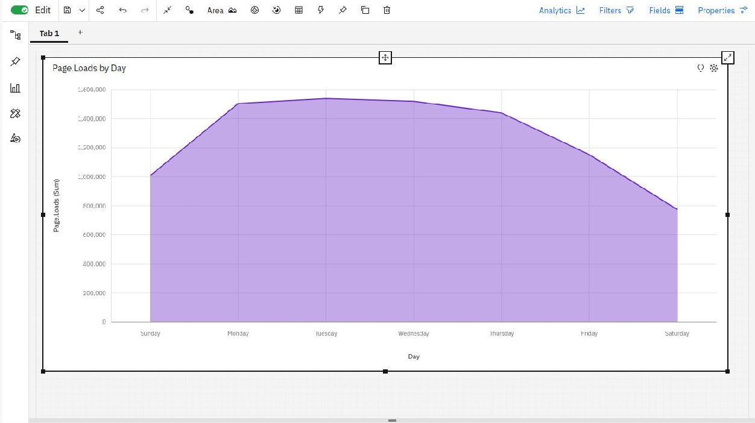

1. Visualising data with respect to worked for Day by Day of Week colored by Day using Point representation:

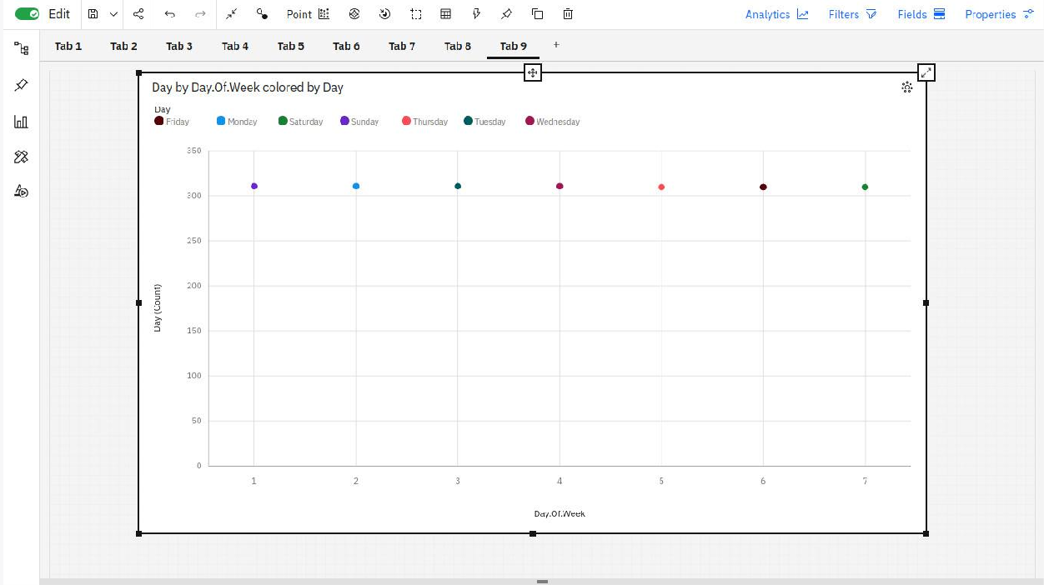

1. Visualising data with respect to worked for Day by Day of Week using Stacked Column representation:

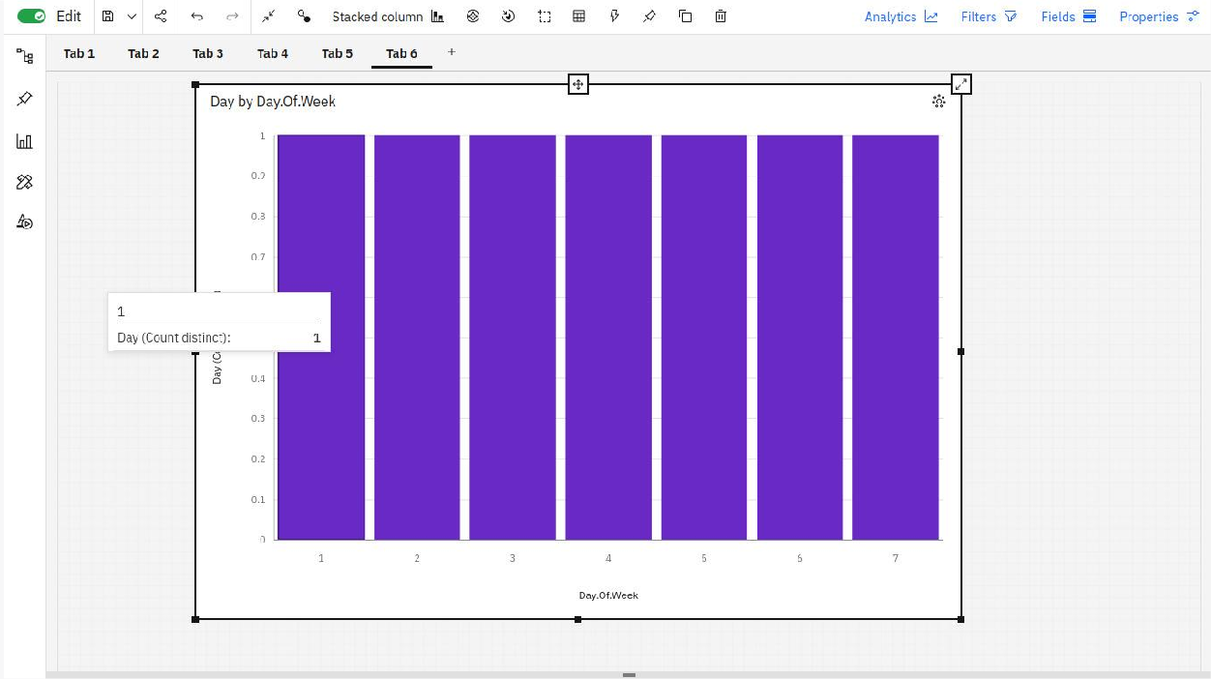

**I.**Visualising data with respect to worked for Day of Week by Day using Summary Map representation:

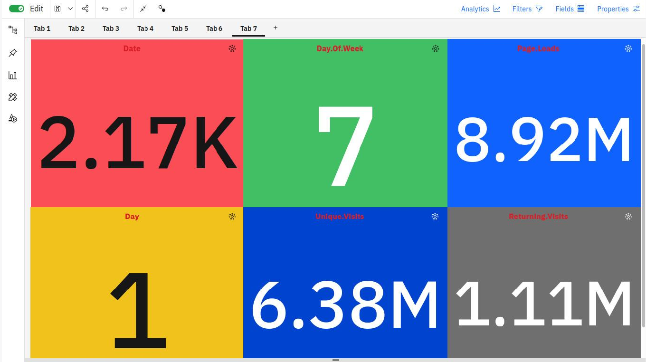

## 2.Data Explorations:

In the context of website traffic analysis, data exploration involves examining various metrics related to user interaction with the website. This includes studying parameters such as the number of visitors, page views, session durations, referral sources, and user engagement patterns. By exploring these data points, businesses can identify trends, user preferences, and potential areas for improvement on the website. Data exploration in website traffic analysis helps in understanding user behavior and optimizing the website to enhance user experience and achieve business objectives.

**Visualsing data with respect to worked for Day by Day of Week using data**

**exploration :**

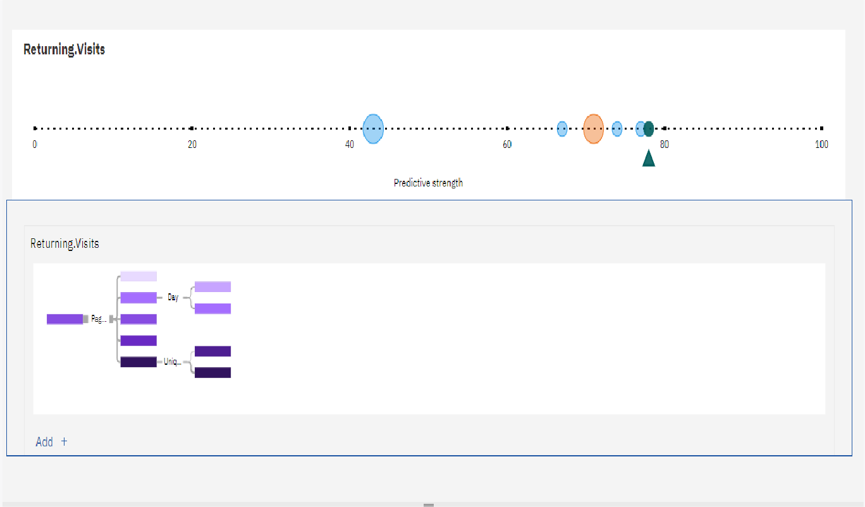

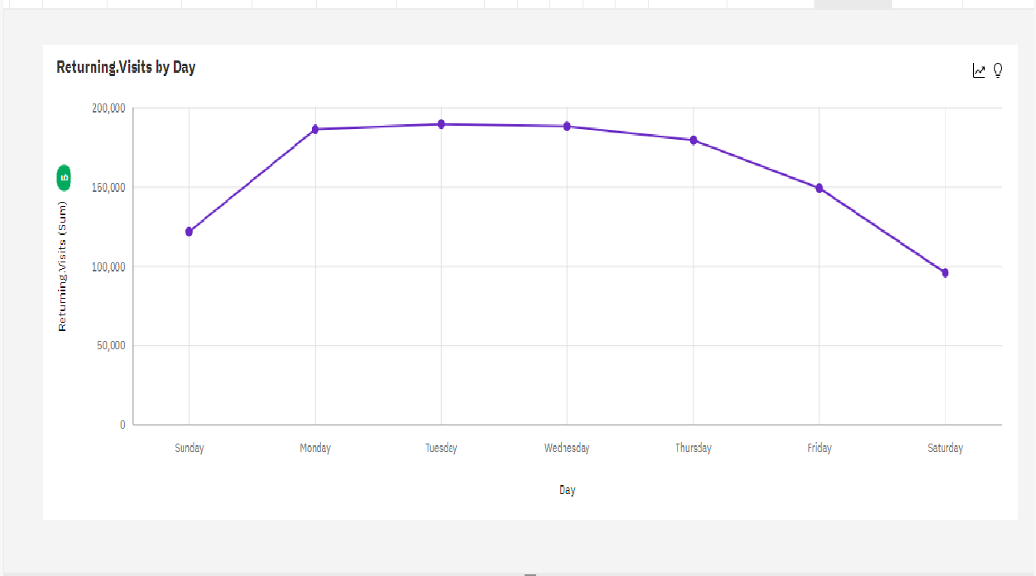

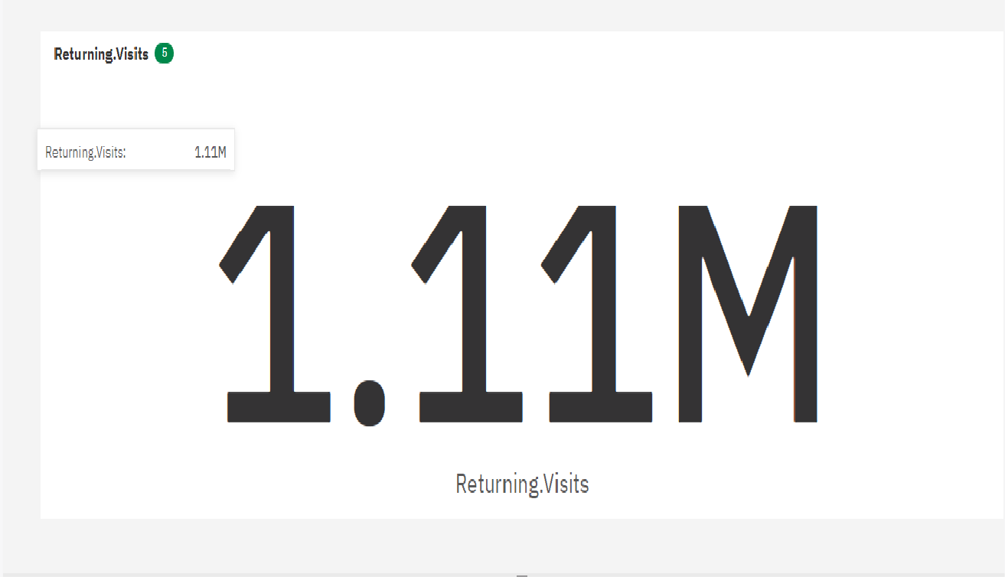

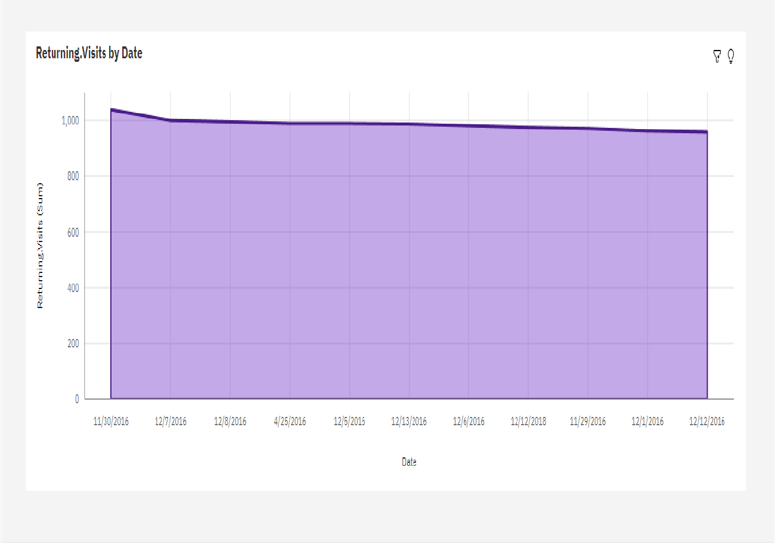

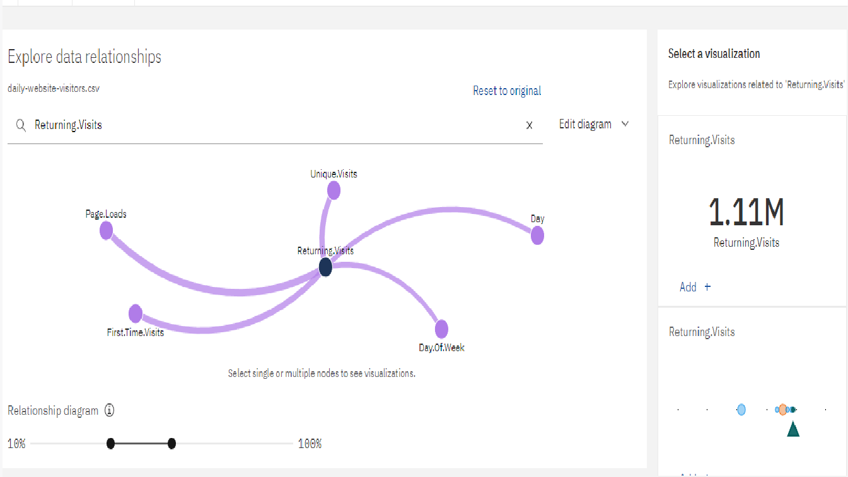

# Conclusion:

Data exploration and visualization process, it's essential to summarize the key insights and findings from the analysis. This involves highlighting any notable patterns, trends, correlations, or anomalies identified in the data. Additionally, you should discuss the implications of these findings and their relevance to the initial research questions or objectives. Finally, it's crucial to consider any limitations or assumptions made during the analysis and suggest potential avenues for further investigation or refinement of the data.